**Oregon State University • Department of Civil and Construction Engineering**

**CE 593 Traffic Flow Theory**

**Final Project: Fundamental Diagram Calibration During Natural Hazards**

**Description:**

*The Underlying fundamental diagrams*

Fundamental diagrams have an array of applications and can be easily interpreted as the core traffic features that depict the prevailing conditions of the segment. In class you have been shown these diagrams, q-k, q-v, and v-k for numerous sections of road in the US. An example for one of the three core distributions (v-k) relationship is shown below utilizing data from GA-400. In this depiction, the red + are the empirical data collected from the roadway, with the remaining single regime models fitted against this data.

Figure 1 Example Performance of single-regime models

Despite the individual efforts, and the ability for these models to portray relative accuracy against the empirical data, there have been more recent models that require additional parameters. Those such models of note are the 5-parameter logistic (5PL) model and the S3 model (Wang et al., 2011; Cheng et al., 2021) those models and some of the single-regime models are shown in Table 1.

Table 1 Single-regime models to be considered.

|  |  |  |
| --- | --- | --- |
| **Single-regime models** | **Functional Form** | **Parameters** |
| *Greenshields* |  |  |
| Drake | ] |  |
| 5PL - change |  |  |
| S3 |  |  |

Although these later models are more complex and require additional parameters, there is an expectation for the underlying distribution of the models to transform based on those parameters. An example of this is demonstrated in Figure 2 where adjustments to the jam density within the 5PL model are shown.

Within these two figures, one can see the increasing changes to the free flow speed, and average speed of stop and go traffic, and how these variations adjust the basic fundamental diagrams, in this case the (v-k) diagram.

Figure 2 Effects of varying parameters, and within the 5PL model (Wang et al. 2011)

In the case of altering the free flow speed, , there is a substantial increase in the spread of speeds as a function of density in the low-density region (<40veh/km). We see the opposite effect from the variation with the average speed in the stop and go traffic parameter, , where a large variance of speed is observed in the high-density region. Simply fluctuations in these parameters are visually revealing, altering the base fundamental diagram.

As such, in an actual traffic stream, these parameters would eventually get calibrated based on some prevailing traffic conditions and its subsequent data. If one were to identify a broad range of values that, in the case of the above diagrams and the use of the 5PL model, for both and where there are substantial differences of these values, the state of traffic, ranges of capacity and even travel times will also vary significantly. It is these reasons why an investigation into the underlying traffic parameters for some key models, which portray these fundamental relationships, are desired to be understood in the context of normal traffic operations and those that occur during an evacuation of a natural hazard.

*Study areas and natural hazards*

With the above discussion we look towards two different natural hazards that that produced evacuation flow traffic parameters. The first occurred on SR-91 (Florida’s Turnpike) during the evacuation for Hurricane Irma between September 6 – September 9, 2017, in Florida. A depiction of the timeline of the hurricane and the resulting speed contour are shown in Figures 3 and 4.

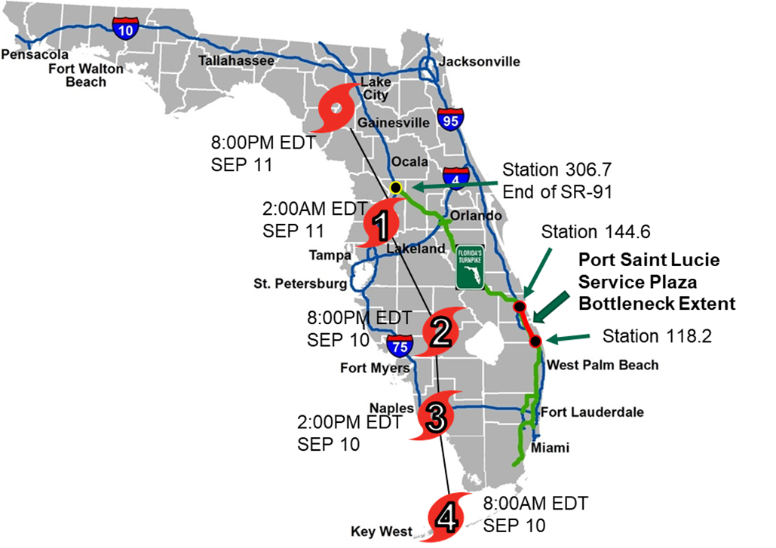

Figure 3 Hurricane Irma Track Staes et al., 2020.

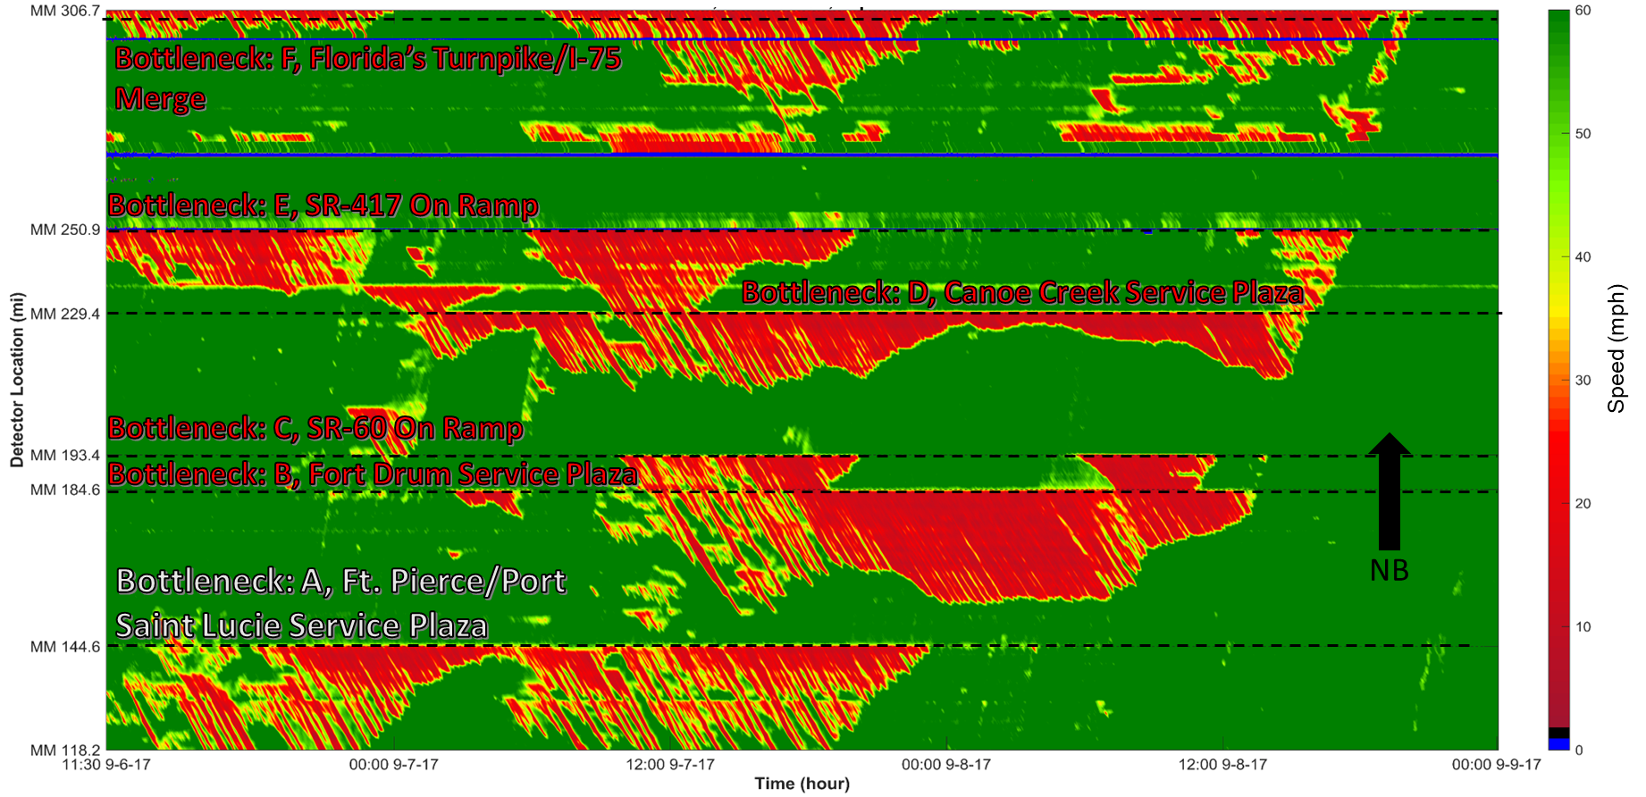

Figure 4 SR-91 Speed Contour from Hurricane Irma Evacuation September 2017

Proceeding this, another event was found to produce significant queueing as a result of a wildfire near Santa Rosa, California in response to the Kinkade Fire from October 23 – November 6, 2019, on US-101SB. An example of one speed contour during that event is shown below in Figures 5, with the map of the associated evacuation order in Figure 6 in the Appendix.

Figure 5 US101-SB Speed Contour from Wild Fire Evacuation October 2019

**Instructions: You are given a series of problems related to the entire process of calibrating and recreating the fundamental diagrams of several single-regime traffic flow models. Each step will lead towards the completion of the project.**

**Task 1: Data Cleaning (due date)**

You are given 4 sets of data, two sets of dets for normal operations and two during an actual evacuation that has occurred. These datasets come from two separate data repositories: RITIS – the Regional Integrated Transportation Information System and PeMS the Caltrans Performance Measurement System. A depiction of both datasets is shown below:



Figure 6 PeMS Detector Readings and Station Metadata

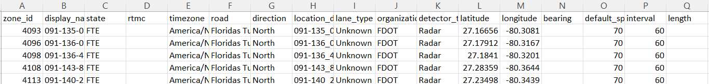Figure 7: RITIS Detector Readings and Station Metadata

With the above snapshots for both sets of data one can make the distinction that the RITIS is already converted into zonal estimates with a polling interval of 1-minute, where the volume is the sum of vehicles observed in all lanes at that station for that duration of time, the speed is the volume weighted speed show in **Equation 1**:

|  |  |
| --- | --- |
|  | (1) |

Where L is the total number of lanes at the station reading location

Moving towards the PeMS data within Figure 6, this data is polling at 30-second intervals and comes in an unaggregated form. Startin in Column C within the first image in Figure 6, the is the volume of the most interior lane, Column D and E the Occupancy and Speed for that most interior lane. The lane numbering works from the interior to the exterior lanes, so lane 5 would be the nearest to the shoulder. It can also be observed that not all of the locations have 5 lanes, which is going to be an individual challenge when aggregating this data.

***Deliverable 1:*** ***Converted PeMS dataset into a singular zonal reading file, similar to that from RITIS. [Two Zonal Reading Files.csv files]. Students should also see errors within the data such as averaging of occupancy when no vehicles are present.***

**Task 2: Generating flow, density, and speed contours (due date)**

One of the next procedures that leads towards an understanding of where congested traffic occurs along the roadway segment is to visualize this data as one contour, an example of speed contours for both facilities are shown in 4 and 5. An example of this is shown in Table 3, where each entry in the matrix is the aggregated flow, speed and density for the detector () during the specific time period (). For simplicity all three variables are in the same cell, however within the submission this should be three separate files where the cell value is flow, speed and then density. Moreover, the first column should be the most upstream detector and each column should be the next detector going downstream, and first row should be the first timestamp observed in the data (this can be rounded to the nearest 30-seconds in the case of the PeMS data and 1-minute for Ritis and increasing until the last measurement.

A last note for the density measurements, as the data is utilizing occupancy, the team will need to convert the occupancy to density for all of the locations, this can be done following the following density occupancy conversion in **Equation 2:**

|  |  |
| --- | --- |
|  | (2) |

Where , is the average vehicle length and is the detector length: consider these values to be 18-feet and 6-feet respectively.

Table 3: Flow, Speed and Density Contour Matrix:

|  |  |  |  |
| --- | --- | --- | --- |
|  | **Detectors** | | |
| **Time** |  |  |  |
|  |  |  |  |
|  |  |  |  |
|  |  |  |  |

***Deliverable 2: Flow, density, and speed contours for US101 and SR91 datasets during the evacuation events and after. [12 total .csv files]***

**Task 3: Generation of Macroscopic Fundamental Diagrams from selected detectors identified from speed contours:**

With the generated contours the research team is tasked with producing the fundamental diagrams (q-k, v-k, and q-v) for the selected set of detectors where queuing is observed during the evacuations. Consider Figure 5, the speed contour for US-101, there is no need to keep the data the is downstream of where the queueing took place during the evacuation event (dark blue-purple region in figure 5 where there are low speeds.) From the evacuation event itself you should arrive at a series of detectors where there was queued traffic from the evacuation, with those detectors data the diagrams should be generated and the same detectors, however during the normal operations should also be created.

***Deliverable 3: q-k, v-k, and q-v fundamental diagrams for the selected detector sets at each facility [12 total figures .jpeg, .tif, or .png]***

**Task 4:** Execution of fitting algorithms on identified data towards the calibration of individual parameters for the 4 selected models and statistical comparisons.

Once you arrive at fitted curves (Gauss-Newton iterative optimization of square errors, search this on ChatGPT for a quick example and explanation (the below should look familiar to MSE)

|  |  |
| --- | --- |
|  | (3) |

The above equation is optimizing on all required input parameters for each of the models in relation to the output estimated value for velocity , to the observed velocities and densities, .

From the different data sets and for the four separate models, comparison metric of these values through the use of observed verses estimated from the fitting algorithms (MSE), and comparison of individual facilities between the evacuation day and normal operations through t-tests. It needs to be stated we are testing at the 0.10 threshold for t-tests, and you are comparing the output data from the models with the fitted parameters against the different sets of data. Do not conduct the t-test against the base data sets. Lastly, the MSE is the difference between the fitted dataset and the base data for each density value and should follow the form of **Equation 4**:

|  |  |
| --- | --- |
|  | (4) |

Where , is the observed speed for the specific density value.

When conducting the MSE the only fundamental diagram to consider is the v-k relationship as all other diagrams are produced out of the fundamental relationship: q=vk.

***Deliverable 4: Final optimized parameters for each of the models based on the four different datasets, MSE for all four models on each of the roadways and days, lastly the final t-test values for the comparison of evacuation versus normal operating conditions.***

**APPENDIX**

